



Excel and Copilot for Data Productivity
LAB MANUAL

Disclaimer: The content is curated from online/offline resources and used for educational purpose only
Lab 1.4 - Using Copilot in Excel
Task:
Learners will work with the provided Product_Catalog_Dataset.xlsx in Excel and use Microsoft Copilot Chat as their Excel consultant to generate formulas, perform calculations, and extract insights. The dataset contains product information such as product name, buyer name, price, MRP, ratings, total number of ratings, discount percentage, and seller. Learners will practise describing this data structure clearly to Copilot, asking for specific formula help, and implementing AI-suggested solutions in the spreadsheet.
Equipment Required:
- Computer with internet connection and web browser.
- Access to Copilot and Excel Online or Offline (Two browser tabs open simultaneously for the workflow.)
- Provided file: Product_Catalog_Dataset.xlsx
Prerequisites:
- Ability to navigate Excel interface, identify cells, columns, and rows.
- Understanding of basic business concepts such as revenue, profit, and averages.
Problem Statement:
You have joined the analytics team of an online fashion retailer that sells clothing on a marketplace and the company has shared its product catalog dataset with you in Excel format. The dataset contains the following columns:
- ID – Unique product identifier.
- Product_Name – Name or description of the product.
- Buyer Full Name – Name of the customer who bought the product.
- Price – Final selling price paid by the customer.
- MRP – Maximum Retail Price printed on the product.
- Rating – Average rating given by customers (out of 5).
- RatingTotal – Total number of ratings received.
- Discount – Discount percentage offered on the product.
- Seller – Name of the brand or seller.
Your manager wants quick answers to several questions:
- How much money are customers saving due to discounts?
- Which sellers are offering the highest average discounts?
- Which products or sellers have the highest ratings and most customer feedback?
- Are there products where the discount seems high but the rating is low?
Manually analysing this dataset and writing formulas from memory would take a significant amount of time and requires remembering complex Excel syntax. Your challenge is to use Microsoft Copilot Chat as your Excel assistant to help you construct formulas and extract insights from the Product Catalog Dataset within 20 minutes. You must correctly describe the dataset to Copilot, apply the formulas in Excel Online, and interpret the results to answer business questions.
Procedure:
Part 1: Opening the Dataset in Excel Online
- Open your web browser and keep both the tabs open.
- Upload the file in Excel.
- Double-click the Product_Catalog_Dataset.xlsx file to open it in Excel Online.
- Wait for the workbook to load fully and check that you can see the data.
- Confirm that the column headers in Row 1 are: ID, Product_Name, Buyer Full Name, Price, MRP, Rating, RatingTotal, Discount, and Seller.
- Click any cell inside the data range (for example, cell A2).
- Go to the Insert tab in the Excel Online ribbon and click on Table.
- Ensure that the option My table has headers is checked, then click OK.
- Your dataset is now formatted as a table, which makes analysis easier and works well with formulas.
Part 2: Describing the Dataset to Copilot Chat
- In the Copilot Chat text box, type the following description of your data: "I am working with an Excel table containing a product catalog. The columns are: ID, Product_Name, Buyer Full Name, Price, MRP, Rating, RatingTotal, Discount, and Seller. Price and MRP are numeric values, Rating is a number out of 5, RatingTotal is the count of ratings, Discount is the discount percentage, and Seller is the brand name. I want help creating formulas to analyse this data."
- Press Enter and read Copilot’s response. It may summarise ways it can help with this dataset.
- This step ensures Copilot understands the context before you ask for specific formulas.
Part 3: Calculating Discount Amount and Savings
- In Copilot Chat, type this prompt: "In my Excel table, Price is in column D and MRP is in column E. Please give me an Excel formula that calculates the discount amount in rupees for each product as MRP minus Price. I want to place this formula in a new column."
- Press Enter and wait for Copilot to provide a formula, which will likely be similar to:
=E2 - D2 (for the first data row).
- Copy the formula text from Copilot.
Part 3: Screenshot 1
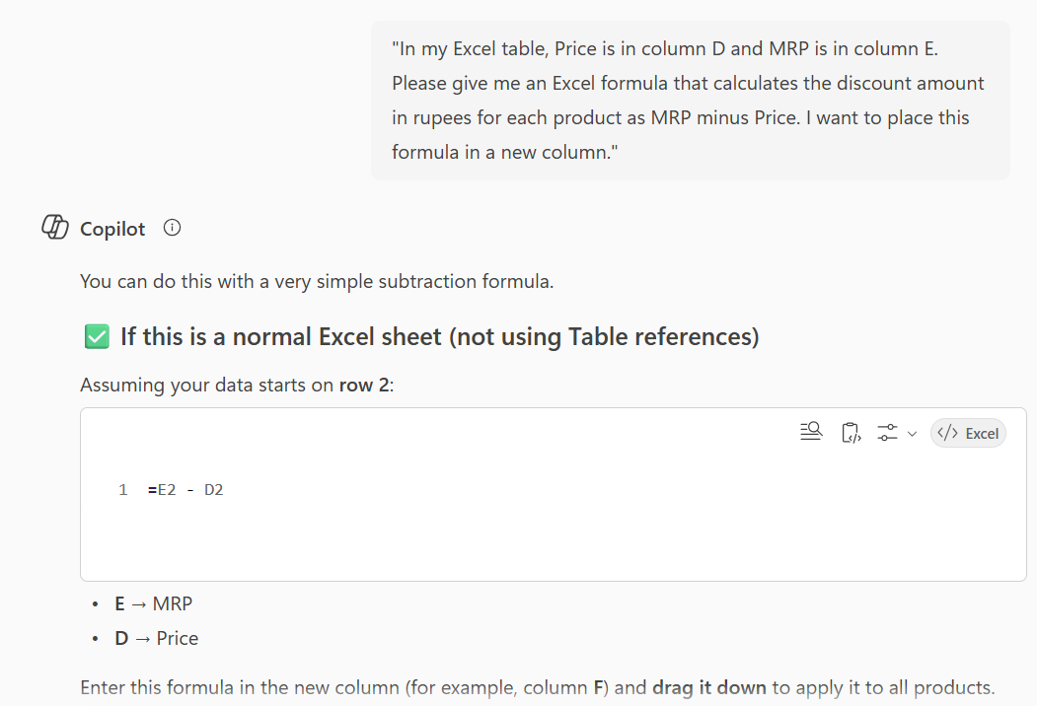
- Switch back to your Excel Online tab containing the dataset.
- Click on the first empty header cell to the right of your existing columns (for example, cell J1).
- Type the new header: Discount_Amount.
- Click on cell J2 (first data row under Discount_Amount).
- Paste or type the formula suggested by Copilot, making sure the row reference starts with 2 (for example =E2-D2).
- Press Enter. You should see the discount amount for the first product.
- Double-click the small square handle at the bottom-right corner of cell J2 to automatically fill the formula down for all rows in the table.
- Select column J and format it as currency using the Home tab and currency format button.
- Now return to Copilot Chat and type: "Please give me a formula that calculates the total discount amount (sum of Discount_Amount) for all products."
Part 3: Screenshot 2
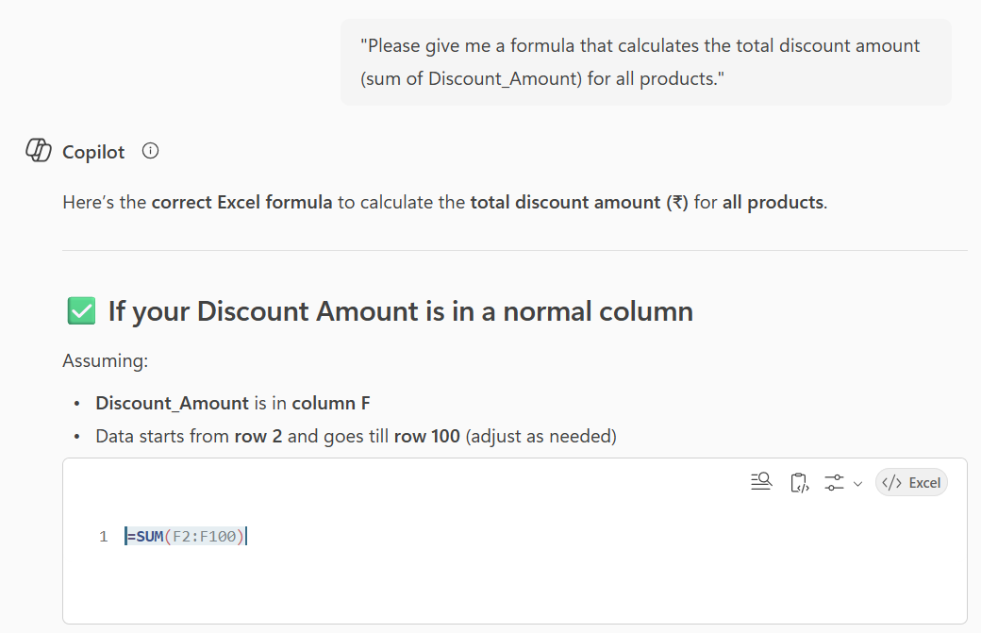
- Copy the suggested SUM formula (for example, =SUM(J:J)).
- In Excel Online, choose an empty cell below your data table (for example J205 or any row after the last record).
- Type the label in the previous column, for example in cell I205: Total Discount Given (₹).
- In cell J205, paste the SUM formula and press Enter.
- This value represents the total amount of rupees customers are saving due to discounts across all products in the catalog.

Part 4: Finding Products with High Discount but Low Rating
- In Copilot Chat, type: "I want to find products where the Discount is high but the Rating is low. Discount percentage is in column H, and Rating is in column F. Please help me create a logical formula that flags products with Discount greater than or equal to 60 and Rating less than 4. I want the output to say 'High Discount, Low Rating' or remain blank otherwise."
- Copy the IF formula suggested by Copilot (it will likely be similar to =IF(AND(H2>=60,F2<4),"High Discount, Low Rating","")).
- Switch back to Excel Online.
Part 4: Screenshot 1
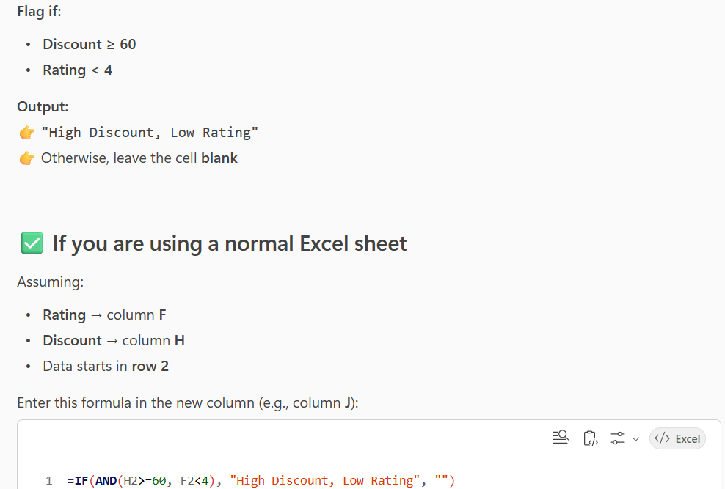
- In the next empty header cell (for example, column K1), type: Discount_Rating_Flag.
- In cell K2, paste the IF formula provided and ensure the row number is 2.
- Press Enter and then fill the formula down for all rows in the table.
- Apply a filter on the Discount_Rating_Flag column and filter to show only rows displaying "High Discount, Low Rating".
- Observe how many such products exist and note what this might indicate, for example potential quality issues or misleading promotions.
Part 5: Identifying Most Popular Products
Step 1: Ask Copilot
In Copilot Chat, type: "I want to create a popularity score based on RatingTotal (column G). Please give me a formula to classify products as 'Highly Popular' if RatingTotal is greater than 1000, otherwise 'Normal'."
Step 2: Create New Column
- In the next empty header (for example, column L1), type: Popularity_Level
- In cell L2, paste the formula similar to: =IF(G2>1000,"Highly Popular","Normal")
Step 3: Fill the Column
- Press Enter.
- Fill down for all rows.
Step 4: Analyse
Apply a filter on Popularity_Level to view only Highly Popular products.
This helps identify:
- Best-selling items
- Products with strong customer engagement
Part 6: Calculating Profit Margin Percentage
Step 1: Ask Copilot
In Copilot Chat, type: "I want to calculate the percentage discount for each product as (MRP - Price) divided by MRP. MRP is in column E and Price is in column D. Please give me the Excel formula."
Copy the formula provided.
Step 2: Create New Column
- In the next empty header (for example, column M1), type: Discount_Percentage_Calculated
- In cell M2, paste the formula similar to: =(E2-D2)/E2
Step 3: Format
- Press Enter.
- Fill down the formula.
- Format the column as Percentage from the Home tab.
Step 4: Interpretation
Compare this calculated value with the existing Discount column to:
- Check data accuracy
- Identify pricing inconsistencies
- Detect unusually high or low discount strategies
This helps the business monitor pricing control and data quality.
Conclusion:
In this activity, you analysed a realistic product catalog dataset instead of a generic sales table. You used Microsoft Copilot Chat as an on-demand Excel specialist to help you build formulas for discount amounts, total savings, average discounts by seller, popularity scores, and logical flags for risk products. You practised translating business questions such as “Which sellers offer the highest average discount?” and “Which products are popular and well rated?” into precise prompts that Copilot could understand. You then implemented the suggested formulas in Excel Online, reinforcing your understanding of functions like SUM, AVERAGEIF, IF, and logical conditions.

Disclaimer:
The results you have generated are using Artificial Intelligence (AI) and are intended for informational and preliminary analysis purposes only. While efforts are made to ensure accuracy, users are strongly advised to independently review, validate, and verify all calculations, observations, and results before relying on them for interpretation, reporting, or decision-making.

